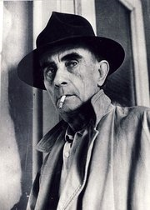**Lajos Kassák** (March 21, 1887 – July 22, 1967) was the most influential artist and theoretician in the Hungarian avant-garde. He was a poet, novelist, painter and essayist and his oeuvre is one of the most complex and influential ones in Hungarian art of the 20th century.

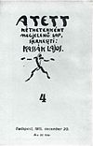Lajos Kassák was born as a son of working-class parents in Érsekújvár (today Nové Zámky in Slovakia). He started to work as a locksmith’s assistant. In 1904 he moved to Budapest, where he participated in the labour union movement, and organized several strikes. He became a writer and artist within the Socialist movement. In 1907 he left for Paris on foot without any money, from where he was expelled back to Hungary in 1910. His experiences were later written down in his autobiography entitled *Egy ember élete* (A Man's Life, 1927–1935). Despite his lack of formal education and his inadequate writing skills, he fought fiercely to publish his works. In 1908 his first poem was published, and his first collections of short stories (*Életsiratás*)in 1912. His first collection of poems *Éposz Wagner maszkjában* *(Epic in the Mask of Wagner) was* published in 1915, and in the same year he launched his first art and literary journal, entitled *A* *Tett* (The Deed), which was anti-militarist and discussed both Socialist theories and avant-garde ideas. When *A Tett* was banned in 1915, he soon started his second, more culturally oriented journal *Ma* (Today)

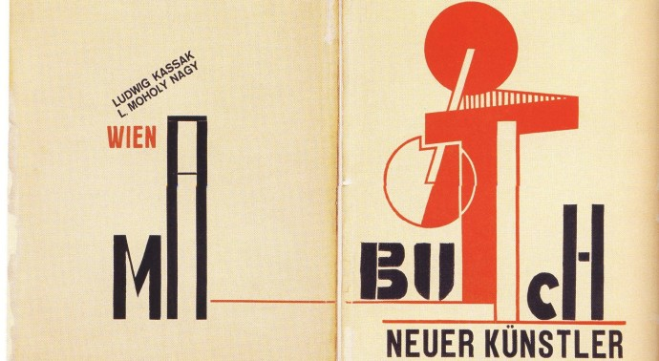At the beginning of the Soviet Republic in Hungary during 1919 he became a member of the special Writers’ Directorate, but after debates with the republic's leader, Béla Kun, he decided to distance himself from Bolshevism. After the collapse of the Hungarian Soviet Republic Kassák was among the first to be arrested by the victorious counter-revolutionary forces. But he always remained leftist and described himself, his art, his view on political and social issues as “Socialist”. In 1920 he immigrated to Vienna, where he continued publishing *Ma,* which developed into one of the most important vehicles of International Constructivism. In 1922, together with László Moholy-Nagy, he published *Buch Neuer Künstler* (Book of New Artists). He returned to Hungary in 1926 and continued editing and publishing journals like *Munka* (Work, 1927-1938) and *Dokumentum* (Document, 1927). Both were independent leftist avant-garde journals. He also organized the Munka-Kör (Work Circle), a group of young Socialist workers, intellectuals, painters and documentary photographers who worked collaboratively. He published poetry, novels and articles extensively during this period.

He founded the journal *Kortárs* (Contemporary) immediately after the War and edited it until it was banned in 1947. He resumed political duties that same year, becoming the head of the Social Democratic Party’s Art Commission, and an MP the year following. With the Stalinist turn of the Hungarian government late in 1948, he was forced to resign, and finally to withdraw from public life. In 1953, he criticized the Party’s cultural policy and was forced to relinquish his membership. He was not allowed to publish until 1956, when he was elected to be a Chair in the Writers’ Association, an influential organization of the era. After the revolution of 1956, the Kádár-regime refused to allow him to travel, exhibit or publish. Nevertheless, he continued to exert a considerable influence both at home and abroad. For example, the prominent French gallerist Denise René organized an exhibition of his work in 1960. In 1966 Kassák participated in the large-scale Dada exhibition mounted by the Zurich Kunsthalle and the Musée d'Art Moderne in Paris. In 1967, the year he died, a retrospective of his work was organized at the Adolf Fényes Gallery in Budapest.

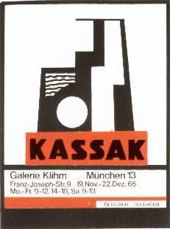Ten years after his death a museum was dedicated to his work and to the Hungarian avant-garde, containing most of his books, papers, photographs and artworks. The opening of the Museum was an important step toward the rehabilitation of the Hungarian avant-garde.

Links:

<http://kassakmuzeum.hu/en/>

http://www.berlinischegalerie.de/ausstellungen/rueckblick/2011/lajos-kassak.html